

|  |  |  |  |  |  |  |  |  |
| --- | --- | --- | --- | --- | --- | --- | --- | --- |
|  | | | | | | | | |
|  | | COMPILER DESIGN | | | | |  | |
|  |  | | | | | | |  |
|  | | | |  |  | | | |
|  | | | | SUBMITTED BY: |  | | | |
|  | | | | SAMAR MITTALMIS: 112315159FACULTY:DR MAYANK LOVANSHI& DR KAPTAN SINGH |  | | | |
|  | | |  | | |  | | |

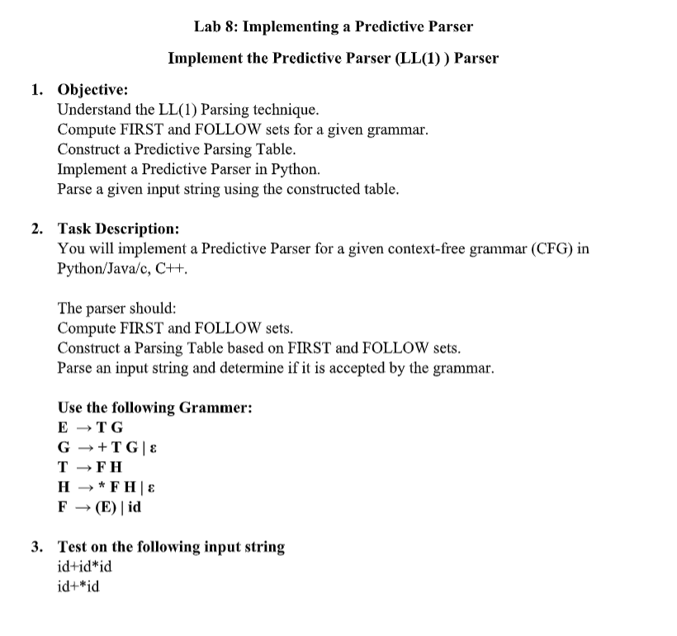

## PYTHON CODE :

rule_set = [

    ("E", ["T","G"]),

    ("G", ["+","T","G"]),

    ("G", ["#"]),

    ("T", ["F","H"]),

    ("H", [ "*", "F",'H']),

    ("H", [ "#"]),

    ("F", ["(", "E", ")"]),

    ("F", ["id"])

]

tokens = {"id", "+", "*", "(", ")", "$"}

symbols = {"E",'G','H', "T", "F"}

transformed_rules = []

first_set, follow_set, parse_table = {}, {}, {}

def remove_left_recursion():

    global symbols, transformed_rules

    new_rules, new_symbols = [], set(symbols)

    for symbol in symbols:

        direct_recur, other_prod = [], []

        for rule in rule_set:

            if rule[0] == symbol:

                (direct_recur if rule[1] and rule[1][0] == symbol else other_prod).append(

                    rule[1][1:] if rule[1] and rule[1][0] == symbol else rule[1]

                )

        if not direct_recur:

            [new_rules.append((symbol, prod)) for prod in other_prod]

            continue

        new_symbol = symbol + "'"

        new_symbols.add(new_symbol)

        [new_rules.append((symbol, prod + [new_symbol])) for prod in other_prod]

        [new_rules.append((new_symbol, recur + [new_symbol])) for recur in direct_recur]

        new_rules.append((new_symbol, ["#"]))

    transformed_rules.extend(new_rules)

    symbols = new_symbols

    print("Grammar after removing left recursion:")

    for rule in transformed_rules:

        print(f"{rule[0]} → {' '.join(rule[1])}")

    print()

def remove_left_factoring():

    global symbols, transformed_rules

    new_rules = []

    for symbol in symbols:

        prods = [rule[1] for rule in transformed_rules if rule[0] == symbol]

        i = 0

        while i < len(prods):

            for j in range(i + 1, len(prods)):

                if prods[i] and prods[j] and prods[i][0] == prods[j][0]:

                    new_symbol = f"{symbol}_{len(new_rules)}"

                    symbols.add(new_symbol)

                    new_rules.append((symbol, [prods[i][0], new_symbol]))

                    new_rules.append((new_symbol, prods[i][1:] or ["#"]))

                    new_rules.append((new_symbol, prods[j][1:] or ["#"]))

                    prods.pop(j)

                    prods.pop(i)

                    i -= 1

                    break

            i += 1

        [new_rules.append((symbol, prod)) for prod in prods]

    transformed_rules.clear()

    transformed_rules.extend(new_rules)

    print("Grammar after removing left factoring:")

    for rule in transformed_rules:

        print(f"{rule[0]} → {' '.join(rule[1])}")

    print()

def compute_first_set():

    for token in tokens | symbols:

        first_set[token] = set()

    for token in tokens:

        if token != "$":

            first_set[token].add(token)

    changed = True

    while changed:

        changed = False

        for left_side, right_side in transformed_rules:

            original_size = len(first_set[left_side])

            if right_side[0] == "#":

                first_set[left_side].add("#")

            else:

                nullable = True

                for symbol in right_side:

                    if not nullable:

                        break

                    first_set[left_side].update(s for s in first_set[symbol] if s != "#")

                    nullable = "#" in first_set[symbol]

                    if nullable and symbol == right_side[-1]:

                        first_set[left_side].add("#")

            changed |= len(first_set[left_side]) > original_size

def compute_follow_set():

    for symbol in symbols:

        follow_set.setdefault(symbol, set())

    follow_set["E"].add("$")

    changed = True

    while changed:

        changed = False

        for left_side, right_side in transformed_rules:

            for index, symbol in enumerate(right_side):

                if symbol in symbols:

                    original_size = len(follow_set[symbol])

                    nullable = True

                    for next_symbol_index in range(index + 1, len(right_side)):

                        if not nullable:

                            break

                        follow_set[symbol].update(first_set[right_side[next_symbol_index]] - {"#"})

                        nullable = "#" in first_set[right_side[next_symbol_index]]

                    if nullable or index == len(right_side) - 1:

                        follow_set[symbol].update(follow_set[left_side])

                    changed |= len(follow_set[symbol]) > original_size

def construct_parse_table():

    for left_side, right_side in transformed_rules:

        if right_side == ["#"]:

            first_production = {"#"}

        else:

            first_production = set().union(

                *(first_set[right_side[i]] - {"#"} for i in range(len(right_side)) if all("#" in first_set[right_side[j]] for j in range(i)))

            )

            if all("#" in first_set[symbol] for symbol in right_side if symbol != "#"):

                first_production.add("#")

        for token in first_production - {"#"}:

            parse_table[(left_side, token)] = right_side

        if right_side == ["#"]:

            for token in follow_set[left_side]:

                parse_table[(left_side, token)] = right_side

def print_sets():

    print(f"{"SYMBOLS":<10}{"FIRST":<10}{"FOLLOW":<10}")

    for symbol in symbols:

        print(f"{symbol:<10}{','.join(sorted(first_set[symbol])):<10}{','.join(sorted(follow_set[symbol])):<10}")

    print()

def print_parse_table():

    print("Predictive Parsing Table:\n")

    header = ["NT/T"] + list(tokens)

    row_format = "{:<12}" * len(header)

    print(row_format.format(*header))

    print("-" * (12 * len(header)))

    for symbol in symbols:

        row = [symbol]

        for token in tokens:

            row.append(f"{symbol} → {' '.join(parse_table[symbol, token])}" if (symbol, token) in parse_table else "")

        print(row_format.format(*row))

        print("-" * (12 * len(header)))

def parse_input_string(input_string):

    input_string += "$"

    parse_stack = ["$", "E"]

    input_index = 0

    print(f"Parsing: {input_string[:-1]}\n")

    print(f"{'Stack':<30}{'Input':<20}{'Action'}")

    print("=" * 70)

    while parse_stack:

        top_of_stack, current_input_symbol = parse_stack[-1], "id" if input_string[input_index:].startswith("id") else input_string[input_index]

        print(f"{' '.join(parse_stack):<30}{input_string[input_index:]:<20}", end="")

        if top_of_stack in tokens and top_of_stack == current_input_symbol:

            parse_stack.pop()

            input_index += 2 if top_of_stack == "id" else 1

            print(f"Match {top_of_stack}")

        elif top_of_stack == "#":

            parse_stack.pop()

            print("Pop #")

        elif top_of_stack in symbols and (top_of_stack, current_input_symbol) in parse_table:

            production = parse_table[(top_of_stack, current_input_symbol)]

            parse_stack.pop()

            if production[0] != "#":

                for symbol in reversed(production):

                    parse_stack.append(symbol)

            print(f"{top_of_stack} → {' '.join(production)}")

        else:

            print(f"Error: No entry for ({top_of_stack}, {current_input_symbol})")

            return False

    return input_index == len(input_string)

print("Original Grammar:")

for rule in rule_set:

    print(f"{rule[0]} → {' '.join(rule[1])}")

print()

remove_left_recursion()

remove_left_factoring()

compute_first_set()

compute_follow_set()

construct_parse_table()

print_sets()

print_parse_table()

for test_string in ["id+id*id", "id+*id"]:

    print(f"\nInput '{test_string}' is {'accepted' if parse_input_string(test_string) else 'not accepted'}")

    print("-" * 50)

## OUTPUT :

